# indian_economy_tweets_Analysis

# Dataframe:

|  |  |  |  |  |  |  |  |  |
| --- | --- | --- | --- | --- | --- | --- | --- | --- |
| DateTime | Tweet_ID | Content | User_Name | URL | Reply_count | Re_Tweet_Count | Language | Like_Count |
| 2019-06-29 23:14:52+00:00 | 1145108400549875712 | June Sales Data shows Indian Economy Still Growing Fast. #SMI #PMI #India https://t.co/B1Y8EdxVXs | WorldEconomics | https://twitter.com/WorldEconomics/status/1145108400549875712 | 0 | 0 | en | 0 |
| 2019-06-29 19:12:48+00:00 | 1145047483858296833 | @SudhinBhadoria This is insane...Utter madness...n extreme show off now...We cant even wish them to go to dust..So they understand the imp of Money.. .indian economy will be shaken..🙄🙄😏😏 | 4mSingh | https://twitter.com/4mSingh/status/1145047483858296833 | 1 | 0 | en | 0 |
| 2019-06-29 18:52:20+00:00 | 1145042331365568512 | @NBTsunderchand @NBTMumbai Harsh ji is versatile in every news, may be politics, jokes, environment, emotional, world affairs etc.  But sir has to share more for future Indian economy growth. | kopridharmu | https://twitter.com/kopridharmu/status/1145042331365568512 | 1 | 0 | en | 1 |
| 2019-06-29 18:49:15+00:00 | 1145041554731520000 | @rij79 @SteelMinIndia atleast u can comeout with some idea that indian steel cos use raw materials like electrodes from heg and gi, so that no import there and dollars don'tmove out and which will beneficial to indian economy too. | ModiBhaveshA | https://twitter.com/ModiBhaveshA/status/1145041554731520000 | 0 | 0 | en | 0 |
| 2019-06-29 18:14:51+00:00 | 1145032898799476736 | @ATX_fight_club @AOC Economics of cotton.  Cotton produced from slave labour of America (and processed in Manchester) destroyed Indian economy.  India &amp; China were the top 2 global economies until 18th century. | abledoc | https://twitter.com/abledoc/status/1145032898799476736 | 0 | 0 | en | 0 |
| 2019-06-29 18:02:36+00:00 | 1145029817730867205 | @ParaRjs I want my leader @RahulGandhi to prove himself that he was right to jumpstart the Indian economy with the #NYAY scheme. We can try with Chhattisgarh also. | INCPrajjal | https://twitter.com/INCPrajjal/status/1145029817730867205 | 0 | 0 | en | 1 |
| 2019-06-29 18:01:31+00:00 | 1145029543532482560 | Psb are backbone of indian economy.&amp; bankers are its bonemarrow.dont weaken it @nsitharaman @PMOIndia @FinMinIndia @ChairmanIba @narendramodi | anil_patra337 | https://twitter.com/anil_patra337/status/1145029543532482560 | 0 | 0 | en | 0 |
| 2019-06-29 17:23:41+00:00 | 1145020020960854016 | @MahuaMoitra_ ma'am heard your speech in Lok Sabha, hat's off an agree to all the points. Just one request please give a solution to fight with the illegal immigration, because this political population is a virus for Indian Economy. | jaykaushik1 | https://twitter.com/jaykaushik1/status/1145020020960854016 | 0 | 0 | en | 0 |
| 2019-06-29 17:21:08+00:00 | 1145019381166018560 | @guldaar @arifanoor72 @ninoqazi She said 'stole' not invested.BTW the growth of Indian economy was slowest in history of subcontinent during entire British rule. | FAWWI1 | https://twitter.com/FAWWI1/status/1145019381166018560 | 0 | 0 | en | 0 |
| 2019-06-29 16:29:54+00:00 | 1145006486260600833 | Traitors looted Indian economy &amp;bought criminals in executive,legislature,judiciary,religions,decoits&amp;anti social elements. With their support established EVM sarkar. @AamAadmiParty. | Prasadkj1 | https://twitter.com/Prasadkj1/status/1145006486260600833 | 0 | 1 | en | 1 |
| 2019-06-29 16:18:23+00:00 | 1145003587921043456 | Indian economy is down, world economy is.down what govt is taking steps that give fuel to economy... Otherwise very soon manufacturing going to collapse. Service industry has already impacted .... | hpsrana | https://twitter.com/hpsrana/status/1145003587921043456 | 0 | 0 | en | 0 |
| 2019-06-29 16:02:59+00:00 | 1144999712119906304 | Demonization was indeed successful but if its demonetisation then well anyone even with an IQ of TADPOLE would agree that it created an havoc with Indian Economy | chimni_sapna | https://twitter.com/chimni_sapna/status/1144999712119906304 | 0 | 0 | en | 1 |
| 2019-06-29 15:37:05+00:00 | 1144993193995321345 | @iKaustubhMishra @WasiuddinSiddi1 Best student of WhatsApp University. Modi has excellent followers. Modi has excellent knowledge in his entire political science course of plastic surgery, climate change, radar technology, gutter gas use, abbreviated English words, forecast of Indian economy,.... all jumblas. | WalterM38555725 | https://twitter.com/WalterM38555725/status/1144993193995321345 | 0 | 1 | en | 1 |
| 2019-06-29 15:33:28+00:00 | 1144992287006453760 | Professionals being forced to quit in MODI SARKAR only CHEERLEADERS left who can't run Indian Economy at this juncture. | ypmittal1985 | https://twitter.com/ypmittal1985/status/1144992287006453760 | 0 | 1 | en | 0 |
| 2019-06-29 15:15:11+00:00 | 1144987683602567168 | @TimesNow @RShivshankar @surjitbhalla India should become preferred  Manufacturing Hub for Coporates from Every country.  It will create  Mass Manufacturing  Create Millions of New Jobs  Trigger Spending Revive Indian Economy  Give International Companies access to Indian Market  Help Grow Indian Exports Worldwide | ss_gurprit | https://twitter.com/ss_gurprit/status/1144987683602567168 | 0 | 0 | en | 1 |
| 2019-06-29 15:14:38+00:00 | 1144987545056342016 | @TimesNow @RShivshankar India should become preferred  Manufacturing Hub for Coporates from Every country.  It will create  Mass Manufacturing  Create Millions of New Jobs  Trigger Spending Revive Indian Economy  Give International Companies access to Indian Market  Help Grow Indian Exports Worldwide | ss_gurprit | https://twitter.com/ss_gurprit/status/1144987545056342016 | 0 | 0 | en | 0 |
| 2019-06-29 15:10:52+00:00 | 1144986598653607938 | @free_thinker Indian economy under NaMo, is doing alright . Had #CONgress gang come to power with their promises of freebies, India would have become another Venezuela | AdmiSadakKa | https://twitter.com/AdmiSadakKa/status/1144986598653607938 | 0 | 0 | en | 2 |
| 2019-06-29 15:08:47+00:00 | 1144986072914386949 | @CityLondonAlan No... they theft 4 trillion Indian economy, Kohinoor diamond | Anbu14310667 | https://twitter.com/Anbu14310667/status/1144986072914386949 | 0 | 0 | en | 0 |
| 2019-06-29 14:50:21+00:00 | 1144981433095733248 | Let’s recognise the dedicated efforts of #ModiGovt on boosting Indian economy by earning highest ever foreign reserves/forex. We are proud of our popular leadership of Sh @narendramodi- Jai Hind https://t.co/YI6dSsQCLg | HLPATHAK69 | https://twitter.com/HLPATHAK69/status/1144981433095733248 | 0 | 0 | en | 1 |
| 2019-06-29 14:46:02+00:00 | 1144980347676975104 | @dhruv_rathee Same as Indian economy? | avferoz | https://twitter.com/avferoz/status/1144980347676975104 | 0 | 0 | en | 3 |
| 2019-06-29 14:43:35+00:00 | 1144979731131097088 | To all those crying Indian economy has deteriorated since 2014. A slap on your face! | theNameManish | https://twitter.com/theNameManish/status/1144979731131097088 | 0 | 0 | en | 0 |
| 2019-06-29 14:12:49+00:00 | 1144971991230758912 | @ramparts02 @AkshayKatariyaa and most important his role as finance minister in 1990 which literally saved india from collapsing.this is probably d pillar on indian economy right now. | Dbang_bihari | https://twitter.com/Dbang_bihari/status/1144971991230758912 | 0 | 0 | en | 0 |
| 2019-06-29 14:08:52+00:00 | 1144970993443586051 | @RahulGandhi @INCIndia today there is a Birthday of Former PM late Shree #PVNarsimhaRao who gave a too way different direction to Indian Economy and u ppl have not even tweeted a single word for him.This shows how much u guys are still jealous for him | chaitanya1930 | https://twitter.com/chaitanya1930/status/1144970993443586051 | 0 | 0 | en | 1 |
| 2019-06-29 14:07:45+00:00 | 1144970716132958209 | Government cuts interest on small saving!!! What will be its effect on credit system &amp; Indian economy??? https://t.co/skCO567JE7 | ms_sajid7 | https://twitter.com/ms_sajid7/status/1144970716132958209 | 0 | 0 | en | 1 |
| 2019-06-29 14:03:02+00:00 | 1144969527739858945 | @dravirmani @Abhishe39317699 Sir the quality of research work u have done for d reforms in Indian economy and business environment, why u r not part of any advisory council to d current government. I hv studied ur research paper on planning commission website, they r still relevant in the current situation. | IamTheCSR | https://twitter.com/IamTheCSR/status/1144969527739858945 | 2 | 0 | en | 0 |
| 2019-06-29 13:51:00+00:00 | 1144966500266254337 | @arunjaitley Sir with great Honour and Respect I appreciate your Dedication towards building Indian Economy and truly participating in constructive Politics, But with Pain was shocked to see your photography today the Loss in your Energy and Strength with considerably weight loss | AllShroff3 | https://twitter.com/AllShroff3/status/1144966500266254337 | 0 | 0 | en | 0 |
| 2019-06-29 13:37:17+00:00 | 1144963048064442368 | @binodojha999 My dear friend puri Dunia ki economy is samay down fall hai. So please check global economy and then tweet. Indian economy is still under control due to BJP govt. | RAMPRATAPs007 | https://twitter.com/RAMPRATAPs007/status/1144963048064442368 | 0 | 0 | en | 2 |
| 2019-06-29 13:08:09+00:00 | 1144955714516819968 | @RameshB_Indian And whatever he did to become father of indian economy, he did under congress rule. | onebythewindow | https://twitter.com/onebythewindow/status/1144955714516819968 | 1 | 0 | en | 0 |
| 2019-06-29 12:46:57+00:00 | 1144950382084231169 | corrupt late prime minister p.v.narshimarao had done fantastic job for Indian economy,he diverted it charismatically in proper direction .BJP is very found of fine to appreciate late pm p.v.narshimarao . | sunilkumarnahta | https://twitter.com/sunilkumarnahta/status/1144950382084231169 | 0 | 0 | en | 0 |
| 2019-06-29 12:37:58+00:00 | 1144948120150667264 | Indian economy is poised at an inflection point. It is an interesting dilemma which can go either way. The current mandate which the government has got is with the same hope. It would be interesting to see the execution of long term plans to reignite the economy. | ashwani61477739 | https://twitter.com/ashwani61477739/status/1144948120150667264 | 0 | 0 | en | 0 |
| 2019-06-29 12:30:59+00:00 | 1144946360619130882 | "Govt needs to get the Indian economy out of liquidity crisis immediately," says @RachitChawla16  Watch 'The Great Expectations' from #Budget2019 with @ridhimb and Chetan Sharma at 8 pm tonight only on @IndiaAheadNews   @BIMTECHNoida @directorBIMTECH @MediaBimtech https://t.co/X0cD9EA1Ll | IndiaAheadNews | https://twitter.com/IndiaAheadNews/status/1144946360619130882 | 0 | 1 | en | 0 |
| 2019-06-29 12:04:07+00:00 | 1144939601649381376 | The Indian economy’s crisis is not of GDP growth, but a drying up of animal spirits https://t.co/0iAUk4sZbq | vishalvirsingh | https://twitter.com/vishalvirsingh/status/1144939601649381376 | 0 | 0 | en | 0 |
| 2019-06-29 11:55:18+00:00 | 1144937382237466624 | @narendramodi @nsitharaman Please look at the following figure on tax deduction for Salaried and consultation, please increase standard deduction or similar kind of deduction so that salaried person can benifit and can increase the investment boost in Indian economy, https://t.co/vSUGYxIqwS | Maheswaras | https://twitter.com/Maheswaras/status/1144937382237466624 | 0 | 0 | en | 1 |
| 2019-06-29 11:50:25+00:00 | 1144936152299737088 | A stable, policy - reform oriented #ModiGovt and a resurgent #IndianEconomy  #NewIndia  Silver lining: India's current account deficit narrows sharply - The Financial Express https://t.co/rNPO9MCWlh | DrSRaghavachari | https://twitter.com/DrSRaghavachari/status/1144936152299737088 | 0 | 0 | en | 0 |
| 2019-06-29 11:00:25+00:00 | 1144923570931417089 | June Sales Data shows Indian Economy Still Growing Fast. #SMI #PMI #India https://t.co/B1Y8EdxVXs | WorldEconomics | https://twitter.com/WorldEconomics/status/1144923570931417089 | 0 | 0 | en | 0 |
| 2019-06-29 10:56:42+00:00 | 1144922637187112960 | I heard commentator on @BBCWorld mentioning Martina Hingis is helping Indian economy when Sania &amp; Hingis won Wimbledon title in 2015 | anilperugu | https://twitter.com/anilperugu/status/1144922637187112960 | 0 | 0 | en | 1 |
| 2019-06-29 10:50:24+00:00 | 1144921051031191552 | @anandmahindra Absolutely Sir, All Indian diversified Conglomerate's are alone able to achieve the $1trillion target. Still, their is a lot of potential is in Indian Economy to be explored. | definitely_raj | https://twitter.com/definitely_raj/status/1144921051031191552 | 0 | 0 | en | 1 |
| 2019-06-29 10:49:34+00:00 | 1144920838941970432 | @metro_india @ashwani_mahajan @TEAMCAIT @AIOVA3 @PiyushGoyal @CimGOI @swadeshimanch @BJP_RSS look mr goyal &amp; modi g hw these big culprits eating business of smal shops &amp; u stil need more proof#banned them immediatly to bost INDIAN ECONOMY #BANNED WALMART TOO THEY DOING B2C inspite of B2B | Naripjain1 | https://twitter.com/Naripjain1/status/1144920838941970432 | 0 | 0 | en | 1 |
| 2019-06-29 10:38:39+00:00 | 1144918090741948416 | There are many cooks available for spoiling Indian economy foods.. 👌 think it over 🙏🙏 | PankajJ80239839 | https://twitter.com/PankajJ80239839/status/1144918090741948416 | 0 | 0 | en | 0 |
| 2019-06-29 10:25:55+00:00 | 1144914890076766211 | @MonaAmbegaonkar Manmohan Was a Respected slave ... Raghuram Rajan Was A Stupid Bloke Who Destroyed Indian Economy For Long ....  Cancer Was in Body He Kept cooling The Head temporarily Biggest Dumbtard https://t.co/KbdKnaZ6g6 | Shreyas54125712 | https://twitter.com/Shreyas54125712/status/1144914890076766211 | 0 | 0 | en | 0 |
| 2019-06-29 09:54:39+00:00 | 1144907021092700160 | Indian economy bigger than the US in 2050? | NishanthV_ET | https://twitter.com/NishanthV_ET/status/1144907021092700160 | 1 | 0 | en | 0 |
| 2019-06-29 09:46:06+00:00 | 1144904869305651201 | @kartikeya_1975 Bullshit....So next time when someone speaks about Indian economy you will ask if they want to live in Zimbabwe or Somalia?  That idiot is comparing a democratic secular nation with Muslim countries and shameless you gift him a bravo | gokulchan | https://twitter.com/gokulchan/status/1144904869305651201 | 1 | 5 | en | 28 |
| 2019-06-29 08:59:37+00:00 | 1144893171152953345 | .@DhruvaAdvisors is hosting a series of webinars to discuss the probable impact on the Indian economy of the tax proposals in the Union Budget 2019-20. The first of which will be broadcast live at 11.30am GMT. 5pm IST on 5 July 2019. Register today https://t.co/RktrXjpKGO https://t.co/qQO5eKRJQb | IntlTaxReview | https://twitter.com/IntlTaxReview/status/1144893171152953345 | 0 | 0 | en | 1 |
| 2019-06-29 08:49:04+00:00 | 1144890513067130880 | @AkashSr04129986 @utsav1711 Indian economy will reach its 5 trillion mark and then 10 trillion. How much time it will take nobody knows. But these 2 decades belong to us. | Arvindlogin | https://twitter.com/Arvindlogin/status/1144890513067130880 | 0 | 0 | en | 2 |
| 2019-06-29 08:13:59+00:00 | 1144881684174655488 | Ultimate tribute to PV Narasimha Rao! May his soul rest in peace. A lot of the wealth we all have built up over the past 2 decades have been due to the measures introduced by him. He had the wisdom to take a seminal shift in approach to the Indian economy https://t.co/SKJBb31jFf | MukulAg77304674 | https://twitter.com/MukulAg77304674/status/1144881684174655488 | 0 | 0 | en | 8 |
| 2019-06-29 07:35:26+00:00 | 1144871986629242881 | The Indian Economy needs Stimulus, Stimulus, Stimulus .....   Will #Budget2019 deliver the same ? | bns5 | https://twitter.com/bns5/status/1144871986629242881 | 0 | 0 | en | 0 |
| 2019-06-29 07:35:20+00:00 | 1144871959961976832 | @rsprasad Indeed Sir, #DigitalIndia is not only transforming the lives of ever Indian but connecting them with new technologies and knowledge as well. We appreciate your efforts and dedication towards making every indian digital empowered and making Indian economy digitally.  @OfficeOfRSP | iNishant4 | https://twitter.com/iNishant4/status/1144871959961976832 | 0 | 1 | en | 2 |
| 2019-06-29 06:40:20+00:00 | 1144858119828324353 | Seven Indicators that Depicts Indian Economy’s Transformation https://t.co/NW15PVipSL  via NaMo App https://t.co/1j6Ht8QWcO | deepal3 | https://twitter.com/deepal3/status/1144858119828324353 | 0 | 0 | en | 0 |
| 2019-06-29 06:39:36+00:00 | 1144857934733762564 | Reversing the Slide in the Indian Economy https://t.co/FSAUGLmJgv  via NaMo App https://t.co/fqE6zpFiG7 | deepal3 | https://twitter.com/deepal3/status/1144857934733762564 | 0 | 0 | en | 0 |
| 2019-06-29 06:26:42+00:00 | 1144854685389475840 | @PiyushGoyal @dpradhanbjp Industrial development in eastern part will give boost to indian economy.. Thanks on behalf of all odias for approving this initiative. | srikantswain91 | https://twitter.com/srikantswain91/status/1144854685389475840 | 0 | 0 | en | 3 |
| 2019-06-29 06:06:45+00:00 | 1144849665210441728 | @neelkanthmishra on the stage to talk about the Indian economy@CFASocietyIndia #MAW https://t.co/G4jP84ywR1 | dpakmundra | https://twitter.com/dpakmundra/status/1144849665210441728 | 1 | 0 | en | 0 |

# Frequently used words

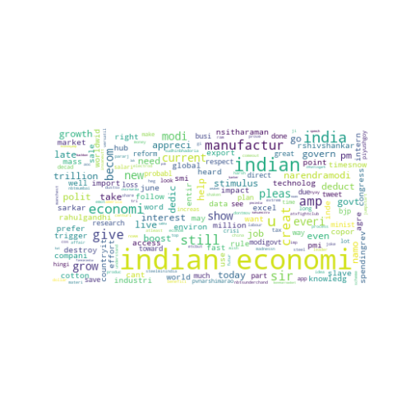

# Frequently used Positive words

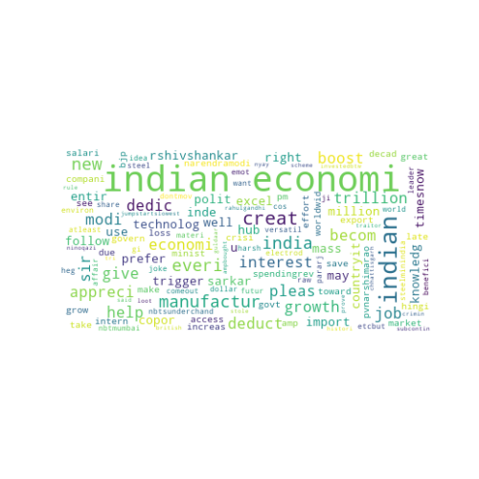

# Frequently used Negative words used

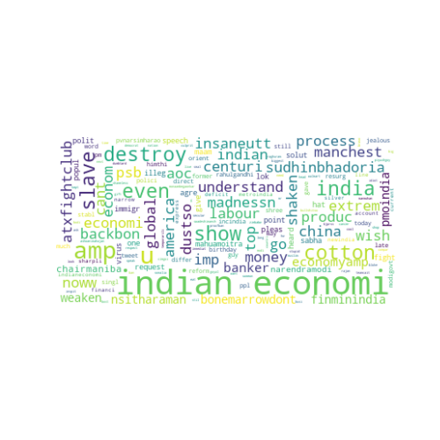

# Top words that repeated in many tweets

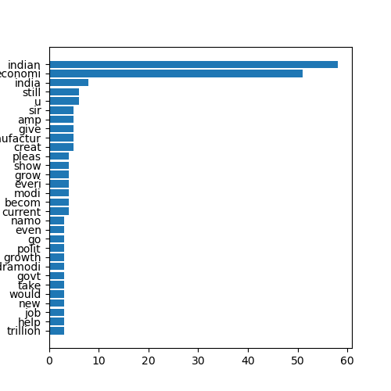

The tweets that frequently contain: Neutral Words🙂

# Overall Scores:

Positive: 6.203999999999999

Negative: 2.2020000000000004

Neutral: 42.594